### DESCON ENGINEERING (Private) LIMITED



*DESCON*

Akhavan House

38 Sir Agha Khan III Road,

P.O. Box 1201, Lahore-54000 Pakistan

Phone: (92-42) 636 5134

Fax: (92-42, 636 4049, 636 6557)

E-mail: Descon@Pmac.Lhe, Imran Pak

Telex: 44326 DSCON PK

**C E R T I F I C A T E**

It is certified that Mr. <Name> Son of Mr. <fname> Worked with us <Designation> at FJFC Project from <From> to <To>.

In the tenure of his service we found him hard working and having vast experience in this field.

We wish him every success in his life.

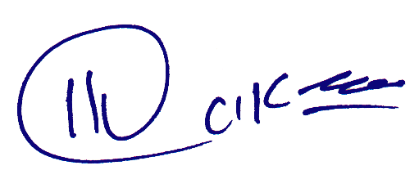

**PROJECT MANAGER**



**EXCELLENCE IN ENGINEERING**

Abu Dhabi Office: Karachi Office: Engineering Works: Manufacturing Works:

P.O. Box 46821, Abu Dhabi, UAE, Phone (971-2) 724 903, Fax: (971-2)782 786, Telex: DESCON EM

Fifth Floor Dawood Center, Maulvi Tamizzuddin Road, Karachi. Phone (92-21) 5682861, 5688544, 5688237-6

Defence Road, Off 24 KM Multan Road, Chungi Lahore. Phone (92-21) 350087, 351741. Fax (92-342) 354836

Ferozepur Road, Lahore. Phone. (92-42) 801582, 801 674, Fax. (92-42) 5810867